Animatronic Face: PROFESSOR DAVID restrepo

Group 7

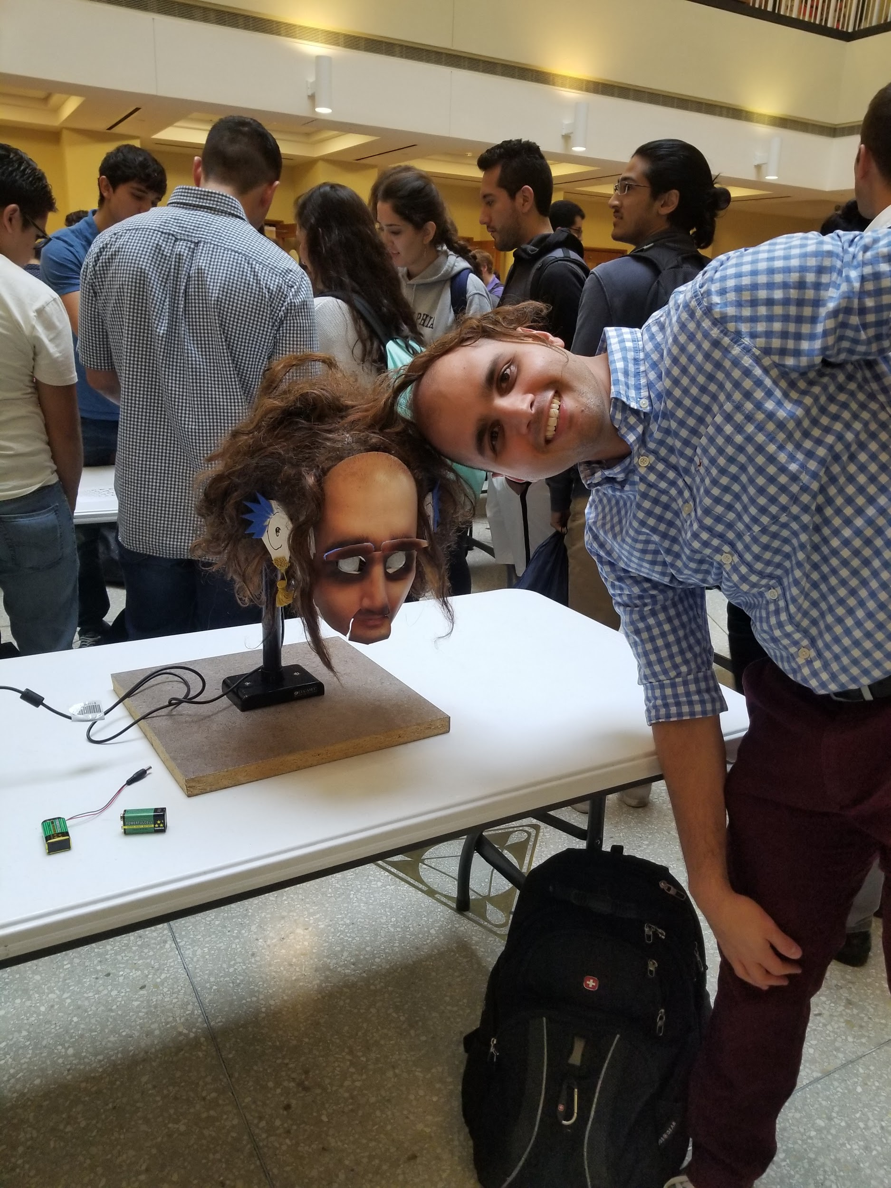

Ruben Hernandez

Dept. of Mechanical Engineering

San Antonio, TX, USA 78249

Rubenhernandez4233@gmail.com

Daniel Mendez

Dept. of Mechanical Engineering

San Antonio, TX, USA 78249

mendezdaniel164@gmail.com

Anmar Jabbar

Dept. of Mechanical Engineering

San Antonio, TX, USA 78249

anmarjabbar007@gmail.com

Submitted as part of project for ME 4543 Mechatronics, Fall 2018

TABLE OF CONTENTS

|  |  |
| --- | --- |
| **Topic** | **Page number** |
| Abstract | 3 |
| Literature Review | 4 |
| Supporting Structure | 4 |
| Joints and Motors | 5 |
| Sensors | 5 |
| Programming | 6 |
| Lesson learnt and suggestions | 7 |
| Personnel and Bill of Materials | 8 |
| Appendix A: Figures | 11 |
| Appendix B: code | 24 |
| Appendix c: Arduino wiring | 28 |

**ABSTRACT**

To gain exposure to the vast and exciting world of robotics, specifically animatronics, UTSA student who were enrolled in the universities Mechatronics course were given a class project. Each group was assigned a UTSA engineering professor to model an animatronic face after. The students were required to use 2 different types of sensors, have a form of playable audio, and have 3 moving parts, of which were to their choosing. Group 7 decided to implement motion in the mouth, ears, and eyebrows with ultrasonic and infrared sensors. The ultrasonic sensor activated motion in the mouth and ears, and played a voice recording of the assigned professor giving a greeting. The infrared sensor activated the movement in ears. All electrical components and wiring were secured inside a custom wooden box that was mounted on a small TV stand. At final demonstration, group 7’s animatronic functioned properly and demonstrated that all requirements were met.

**Section 1: Literature review**

To make a Christmas video back in 2013 [1], using a LEGO Mindstorms Education EV3 core set 45544, Danny’s Lab created a simple animatronic head with three moving parts [2]. The three moving parts were the jaw, eyebrows, and ears. He did not specify what kind of sensors he used in his project description, but he did mention that he used a medium motor for the jaw movement (up/down), and two large motors for the ear and eyebrow movement. After searching up the LEGO set online, it was found that the set includes 3 servo motors, most likely 1 medium and 2 large, and 5 sensors. The five sensors included were a Gyro, Ultrasonic, Color, and 2 touch sensors [3]. A picture of the animatronic can be seen in Appendix A under Figure 1.

On the opposite end of the spectrum, a graduate capstone project submitted to Worcester Polytechnic Institute by Robert Fitzpatrick focused on creating an animatronic head capable of human motioned based off face-tracking software. Initially, Fitzpatrick lead with a polystyrene head for material (Figure 2), however, after receiving the head he realized he could not get much character from that material and eventually decided to continue with a fiberglass head (Figure 3). To determine the types of servo motors he would need he obtained the necessary motor speeds and torques. “The neck roll and neck pitch were decided to be controlled with Hitec HS-7775MG servos, since they have a maximum torque of 9.0 kg-cm and a maximum speed of 0.10 s/60°. This motor is sufficient for both degrees of freedom and is desirable because it has a low profile and both servos could fit within the neck mechanism without any collisions with the links or the neck of the fiberglass bust. The Hobby King HK47011DMG was decided on for the neck yaw motor since it has a maximum torque of 10.80 kg-cm and a maximum speed of 0.07 s/60°. This motor has sufficient torque to rotate the entire head assembly. The Hitec HSG-5084MG was decided on for the eyebrows, eye pitch, eye yaw, eyelids, and jaw servo motors because the motor has a torque of 1.87 kg-cm and a speed of 0.05 sec/60°. Both of these values met the requirements for each of the five degrees of freedom, plus there were few other servo motor options that supplied less torque while still meeting the requirements” [4]. For the face tracking system Fitzpatrick used Gaze Tracker and FaceAPI. A video link was provided in the report [5], however, the video is not currently available.

Lastly, a group of individuals from the IEEE-RAS International Conference on Humanoid Robots in Madrid, Spain, wanted to increase the *fluidity* of robotic face movements. They believe doing this will increase the overall enjoyment of robot-human interactions and make them feel more natural [6]. To do this they used an iCub robot with an articulated talking face created by them (Figure 4). As well as this, a textile cover (Figure 5) was put over the face like a mask. “The standard iCub head houses an on-board PC 104 controller, four electronic boards to control the electric motors a gyro sensor and two Dragonfly camera boards” [6].

**Section 2: Brainstorming (initial planning)**

The animatronic figure that the group will be working on is a face of the professor David Restrepo. The main parts that will be moving on the face robot is the lips, nose, and eyebrows. The team will be using about 4-5 servo motors, one for each part. The face will have an ultrasonic sensor near the eyes to detect any motion that passes in front of the face initialize the set code to begin the motors and sound recording. The most challenging part will be fabricating the support structure and face. To start off, we will create a solid stable base. It will have a beam connected vertically at the center of the base. This beam will be holding the internal frame and the front face. The internal frame supports most of the parts such as the motors, the wires, and the sensors. The power needed for this experiment will be one 9 volt DC battery and between 16 to 20 (1.5V) batteries. The final step will be adding voice audio. All voice audio clips will recorded from the professor. The professor will give phrases such as greetings, pieces of advice, and maybe some jokes. For the output sound signal, a small speaker will be used simultaneously with the ultrasonic sensor. Our goal is to have a sound play when someone waves or passes by the head.

**Section 3: Supporting structure**

The supporting structure consist of a square granite base, a small TV stand connected at the center of the base, a base plate connected to the TV stand (this will hold the animatronic face), and a frame to house all electronic components, motors, and actuators. The frame will be made out of wood or PVC (has not been decided). The frame will be located behind the TV stand which will keep it behind the face. It will also be covered with a cloth sheet to hide the wiring and make the structure more presentable overall.

**Section 4: Joints and motors**

Our animatronic will have a moving mouth, eyes, and eyebrows. They will all have one degree of motion. The eyes will move up and down, the eyes will move side to side, and the ears will move up and down. For the mouth, two servo motors will be used. The movement will be actuated by a rotating rod connected to the mouth that will open and close as the motor spins. The eyebrows will follow this same logic. The eyes will require one servo motor that will be attached into a toothed rod. The servo motor will be retrofitted with teeth that match the teeth in the rod. This rod will then be connected to both eyes, so when the motor rotates, both eyes move in the same direction. As of right now, the servo motors to be used are the J-Deal® 10x Pcs SG90 Micro Servo Motor 9G RC. This motor was chosen strictly on price. It is the cheapest and most commonly used in Arduino projects, however, this is subject to change.

**Section 5: Sensors**

The sensors that we used for this project were an ultrasonic sensor and a Digital Infrared Motion Sensor. The reason why we choose these sensors is to detect motion up close and far. The way the ultrasonic sensor (Figure A.) works it emits an ultrasound at 40,000 HZ which will move thru the air and if it touches on an object it will bounce back to the sensors. The ultrasonic sensor will determine the travel time and speed and will be able to calculate the distance. The ultrasonic sensor has 4 pins on the sensors, a ground pin, voltage pin, trig pin and echo pin. The ultrasonic sensor take a voltage of 5 volts. In order for the ultrasonic sensor to work in the code you must ensure you set the trig on a high state for 10 µs. this will ensure that it send out an 8 cycle sonic gust which will move at the speed of sound and will be received in the echo pin. The echo pin determines the output time in microseconds of the distance the sound traveled. The way the Digital infrared motion sensor (Figure b.) works is that it is a simple motions sensor. It takes a voltage of 5 volts and when it is on it takes a snapshot of the area. If anything moves the alarm pin will send a signal to the controller.

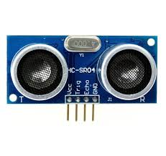

Figure A.

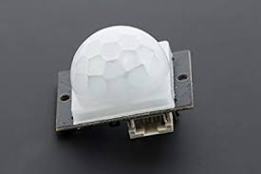

Figure B.

**Section 6: Programming for interaction**

When creating the code the team obtained 2 sensors, 5 motors, 1 MP3 shield and 2 speakers. When implanting the code the team set up the servo motors to control the mouth, ears and eyebrows. When implanting the code the team set up the ultra-sonic sensor to control the servo motors when an object appeared in front of the ultrasonic sensors it set off the servo motors to move the joints. When implanting the infrared motion sensor the team set up the code to control the mp3 shield and the speakers. When an object appeared in front of the infrared sensor it controlled the mp3 shield and set off the voice recorded on the memory card.

**Section 7: Lessons learnt and suggestions (1 page)**

Lesson Learnt:

1. Carpentry
2. Gained knowledge in Arduino Coding,
3. Gained experience in Soldering
4. Time Management
5. Sensor Capabilities
6. Sensor Varieties
7. Servo Motor Rating/Capacities
8. Servo Motor Varieties
9. Thriftiness
10. Adaptation to difficulties (in coding, building, etc.)
11. Creativity in Design
12. Difference Between Stepper and Servo Motors
13. Application of Potentiometer
14. Complexity of Circuit Diagrams
15. Circuit Analysis
16. BJT Analysis
17. Increased Wiring Skill (striping, connecting, etc.)
18. Polymer Plastic Cutting
19. Improvisation
20. Workload distribution
21. Drilling Techniques
22. Arduino Coding Complexity

Suggestion:

1. One thing we as a group could have improved on was the selection of material to house the electrical components and wiring. Another group used Lego Blocks to build a housing which would be comparable in price to using wood, especially if Legos were already owned. It would have also been much simpler to put together.
2. Secondly, perhaps if we managed time even better than we did, additional movements could have been added. The TV mount the electrical housing was on had the ability to turn. If more time was allotted efforts to make the entire animatronic head to move could have been made.
3. Also, a softer and easier to work with material for the face would have been more convenient. It proved rather difficult to cut and drill into the plastic material used for the face.
4. Other sensors could have been implemented as well. In our design we had an ultrasonic and infrared sensor however, an accelerometer could have been used.
5. We could have also obtained more audio to be implemented into the voice activation rather than one greeting.
6. A suggestion would be I would have liked to learn sooner how to control speakers on Arduino

**Section 8: Personnel and bill of materials**

**(a) Personnel**

|  |  |  |
| --- | --- | --- |
| Task | Main Personnel | Secondary personnel |
| structure/chassis | Daniel | Ruben |
| joints and motor interfacing | Ruben | Daniel |
| integrating sensors and interfacing sensors | Amar | Ruben |
| Programing and integration | Anmar | Daniel |

**(b) Bill of materials**

|  |  |  |  |  |  |
| --- | --- | --- | --- | --- | --- |
| No. | Description | Website/comment | Qty. | Unit $ | Total $ |
| 1 | Arduino MEGA 2560 | Provided | 1 | / | / |
| 2 | Small stepper motor | <https://www.sparkfun.com/products/10551> | 5 | 6.95 | 34.75 |
| 3 | Wood | Scrap | / | / | / |
| 4 | white mask | https://www.walmart.com/ip/Loftus-Men-Male-Plain-Anonymous-Matte-PVC-Face-Mask-White-One-Size/143129836?athcpid=143129836&athpgid=athenaItemPage&athcgid=null&athznid=PWVUB&athieid=v0&athstid=CS020&athguid=956eed90-aa0-1677c82a580844&athena=true | 1 | 7.13 | 7.13 |
| 5 | ultrasonic sensor | <https://www.robotshop.com/en/hc-sr04-ultrasonic-range-finder.html?gclid=Cj0KCQiA6JjgBRDbARIsANfu58FK2Of3h5xSDPr2mkp-1kGuY9dM4atJx6kDADqWPKYOYxDNYqkV3c0aAh2aEALw_wcB> | 2 | 2.50 | 5.00 |
| 6 | infrared motion sensor | https://www.dfrobot.com/product-119.html?gclid=Cj0KCQiA6JjgBRDbARIsANfu58Fwju9aKy0lQcYw_glIrngkZQs5XIP30EcYvCFF3RH7rb98aOz9Sw4aArjsEALw_wcB | 2 | 4.40 | 8.80 |
|  |  |  |  | Total price | 55.68 |

The total price for this project excluding the Arduino MEGA was **$55.68**

**Acknowledgements**

* **David Restrepo, Ph.D.**

# Ashok Nedungadi, Ph.D.

# Pranav A. Bhounsule, Ph.D.

**References:**

# [1] Danny’s Lab Animatronic Head Christmas Video

# <https://www.youtube.com/watch?time_continue=43&v=JkhRnaI5uZ0>

# [2] Brief description of project <https://robotics.benedettelli.com/ev3-animatronic-heads/>

# [3] LEGO Store Mindstorm Set <https://education.lego.com/en-us/products/lego-mindstorms-education-ev3-core-set-/5003400?cmp=Shop-US-LEmindstorms-KAC-Jan-18-MINDSTORMS-CPCS-Bing-General-ED-LEGO-&s_kwcid=AL!790!10!81226434007204!25494430652&ef_id=W8nYMQAAAHZm-R-X:20181019135400:s>

# [4] Fitzpatrick’s Project Report <https://web.wpi.edu/Pubs/ETD/Available/etd-050112-072212/unrestricted/Fitzpatrick.pdf>

# [5] Fitzpatrick’s Animatronic Video <http://www.youtube.com/watch?v=nLD8f7VFyHE>.

# [6] iCub Articulation Integration Report <https://hal.archives-ouvertes.fr/hal-01110293/document>

[7] <https://howtomechatronics.com/tutorials/arduino/ultrasonic-sensor-hc-sr04/>

**Appendix A: List of Figures**

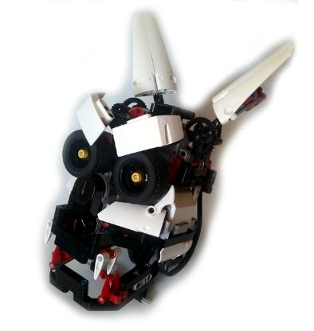

Figure 1: Danny’s Lab Animatronic LEGO head

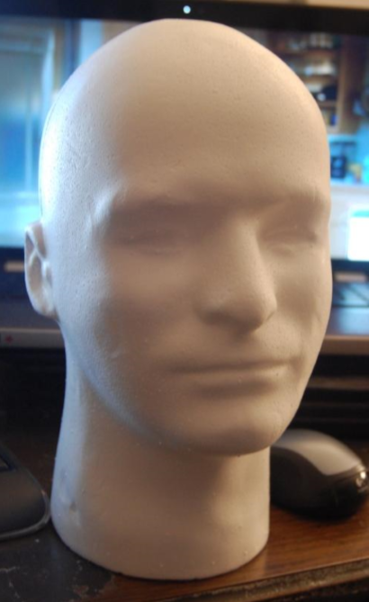

Figure 2: Original Polystyrene Head

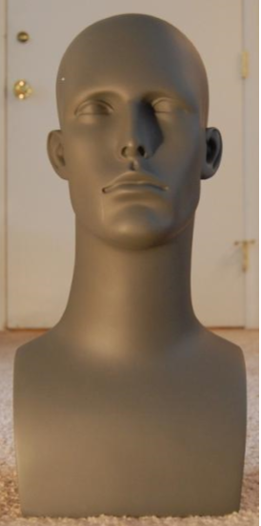

Figure 3: Used Fiberglass Head

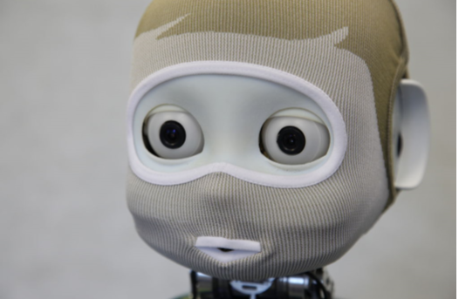

Figure 4: iCub Head

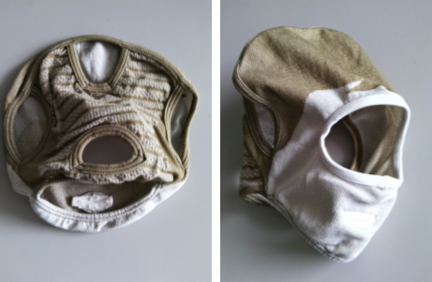

Figure 5: Textile Mask

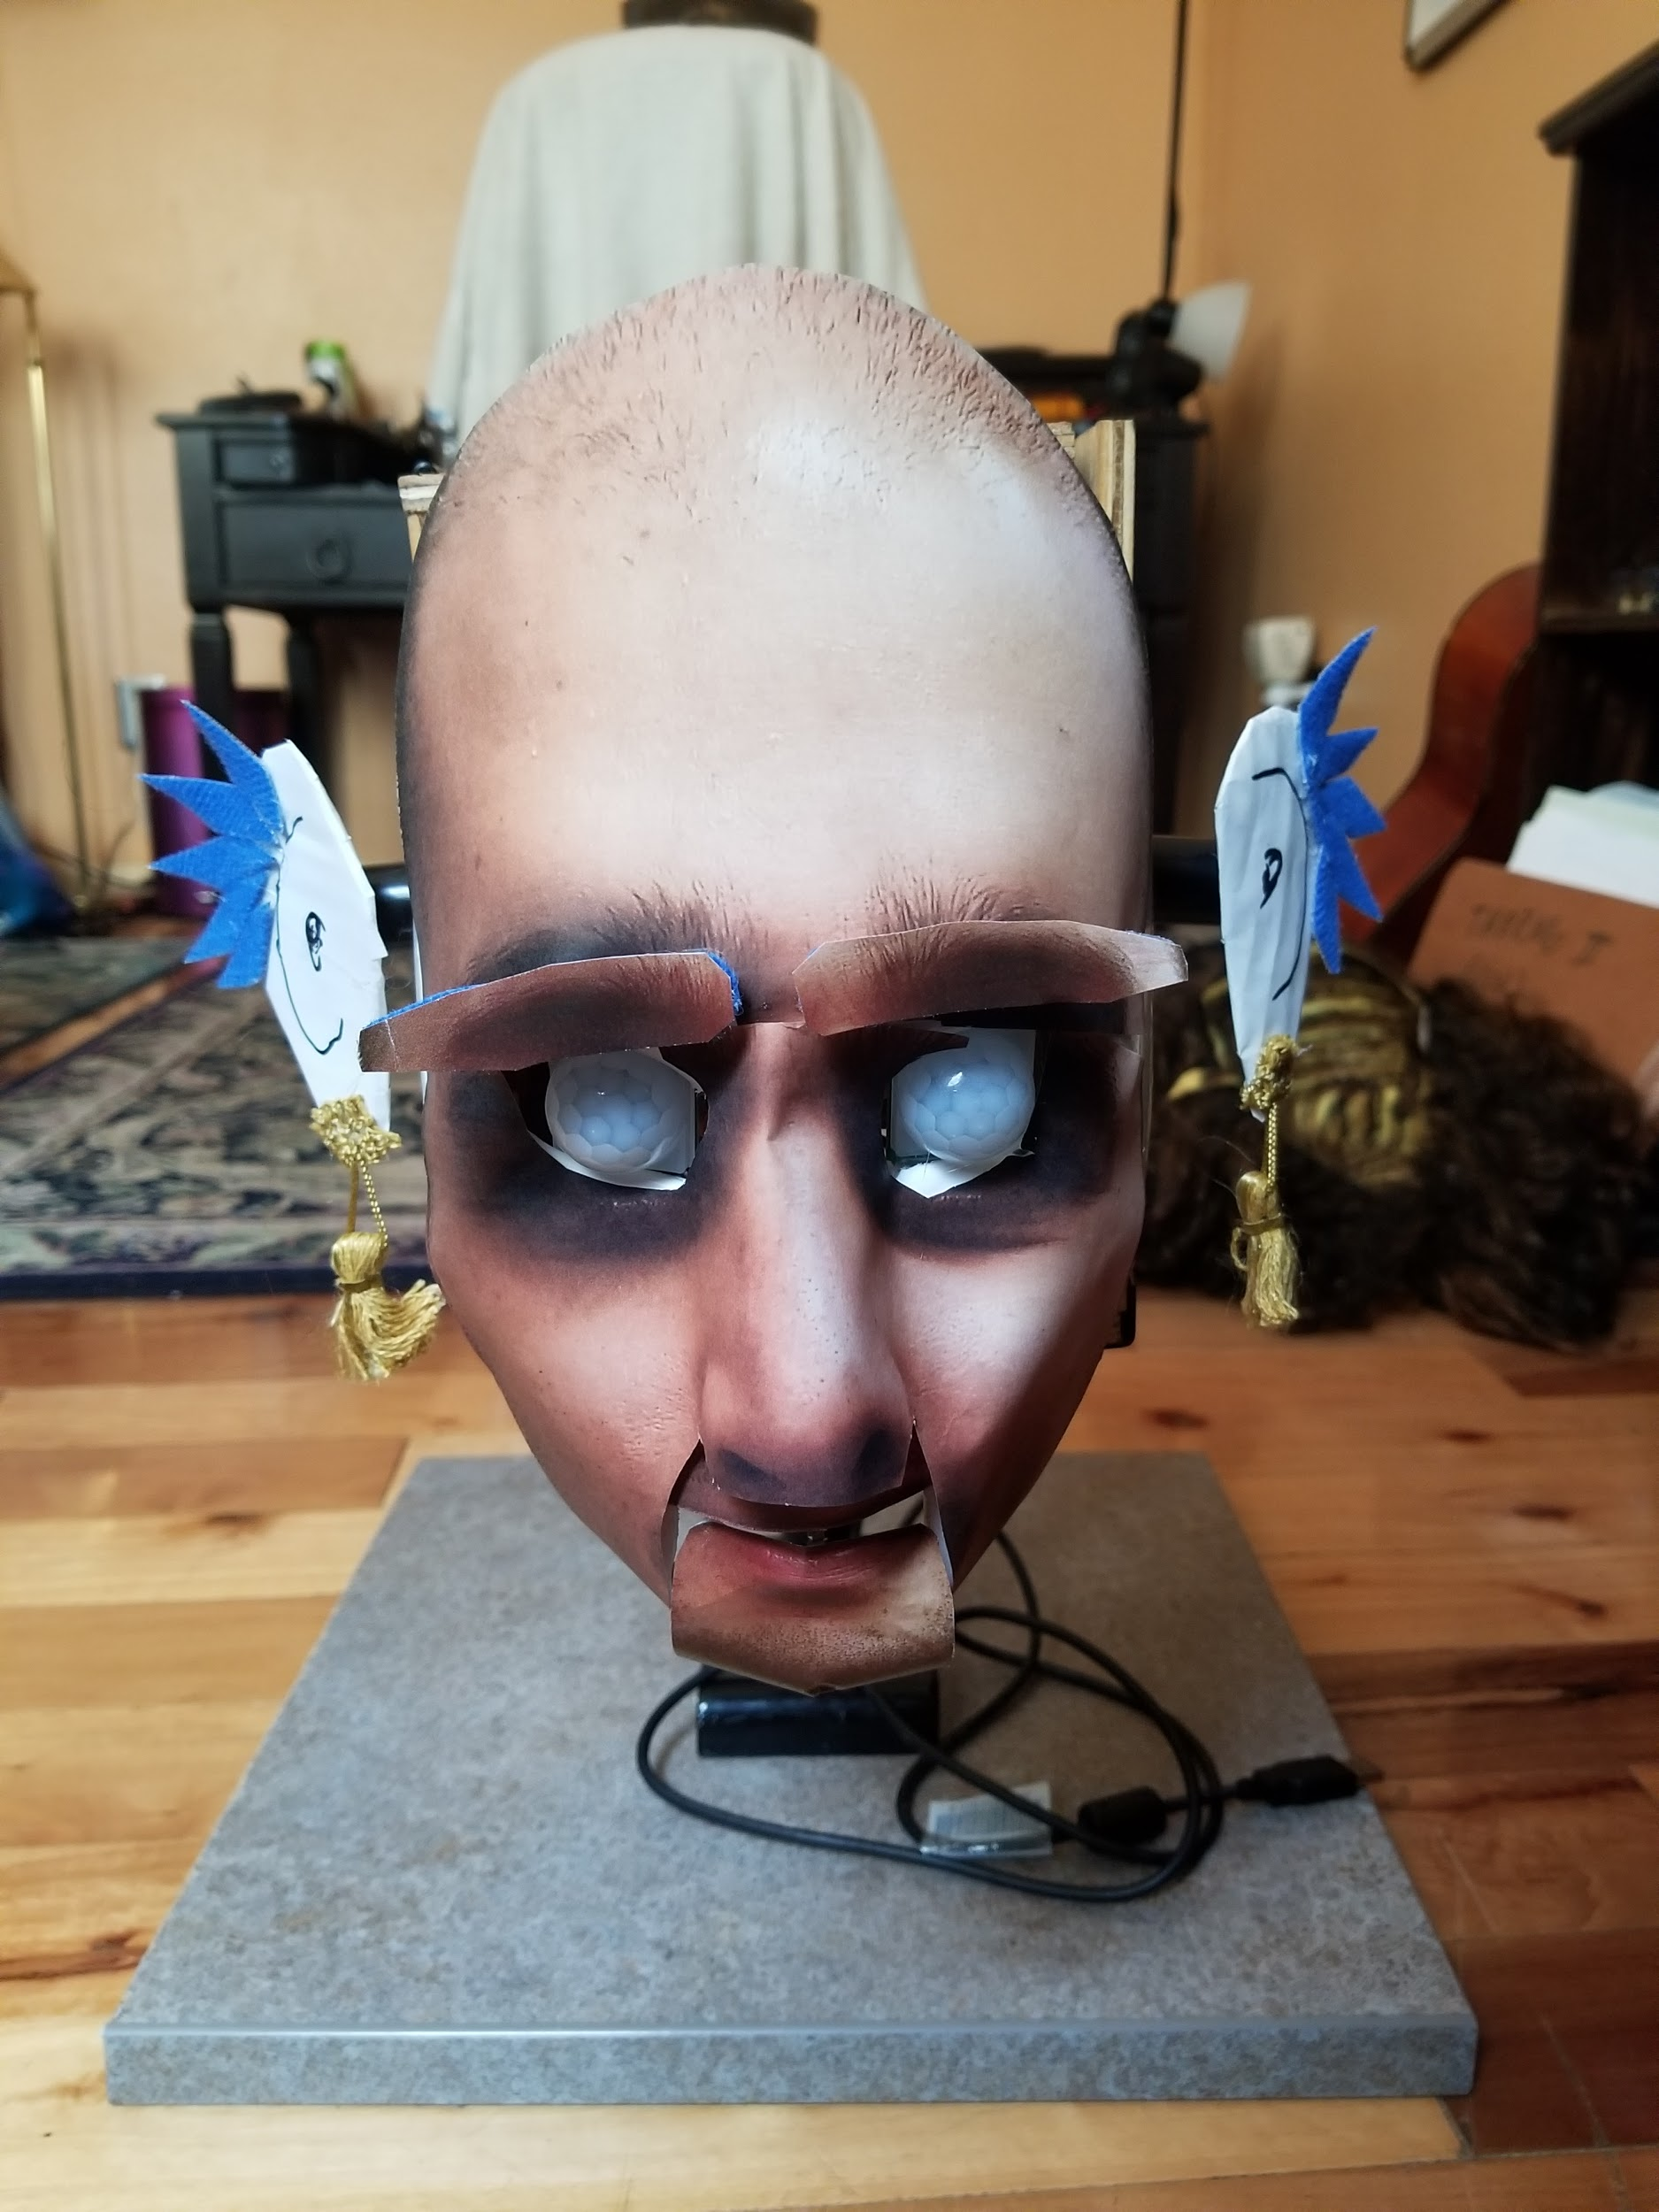

Figure 6.



FIGURE 7.

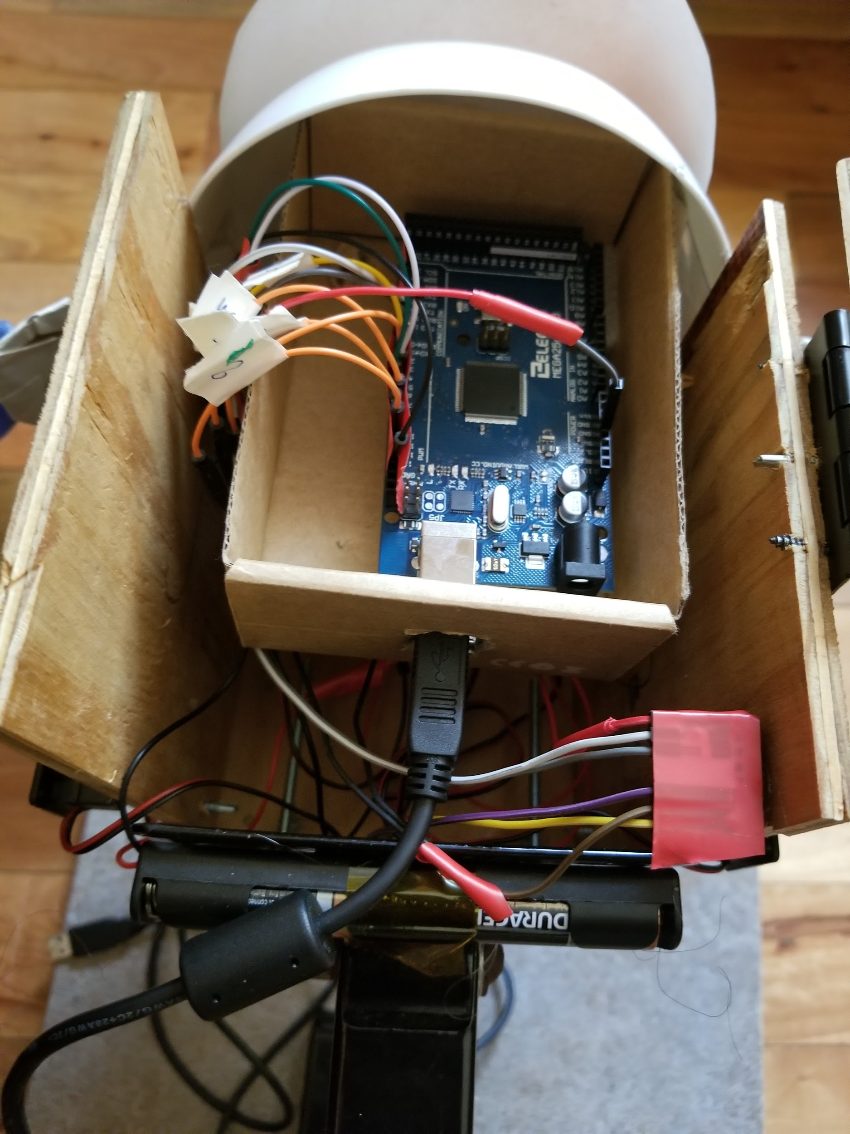

FIGURE 8.

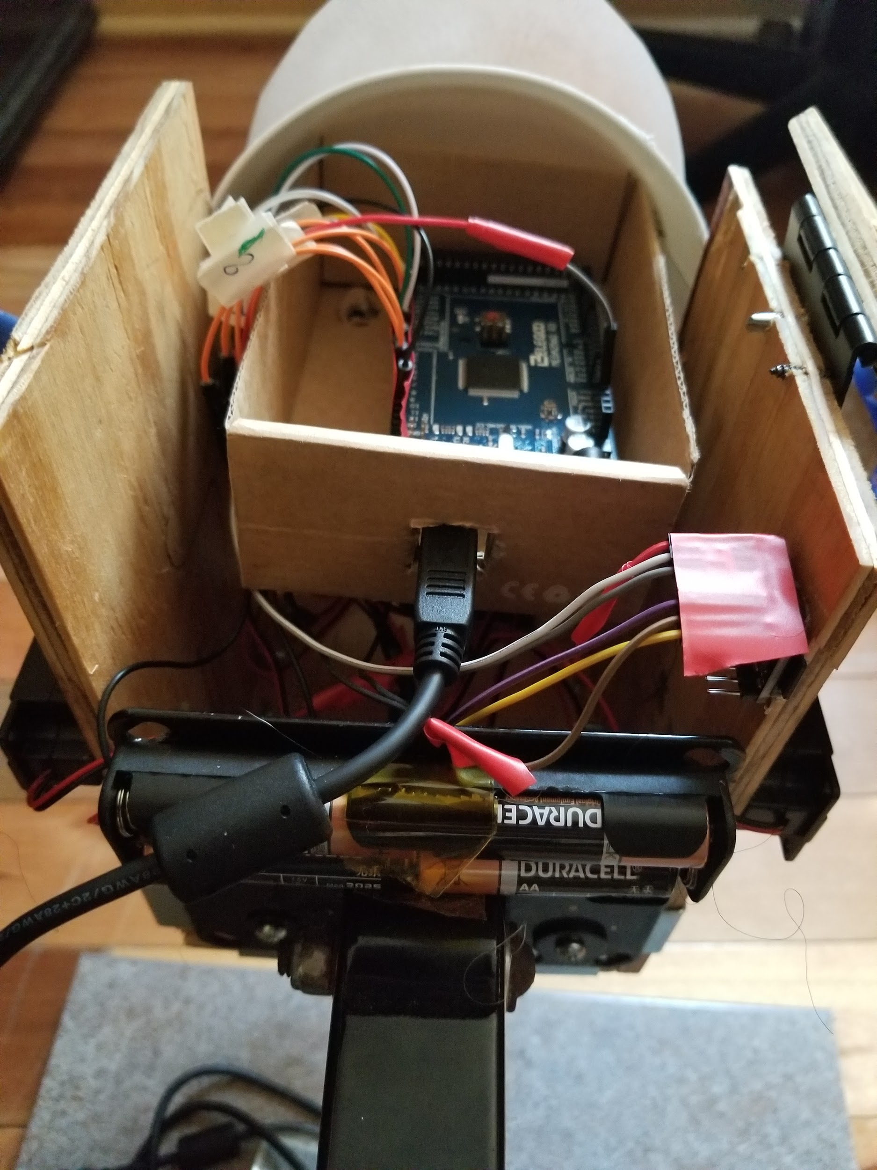

FIGURE 9.

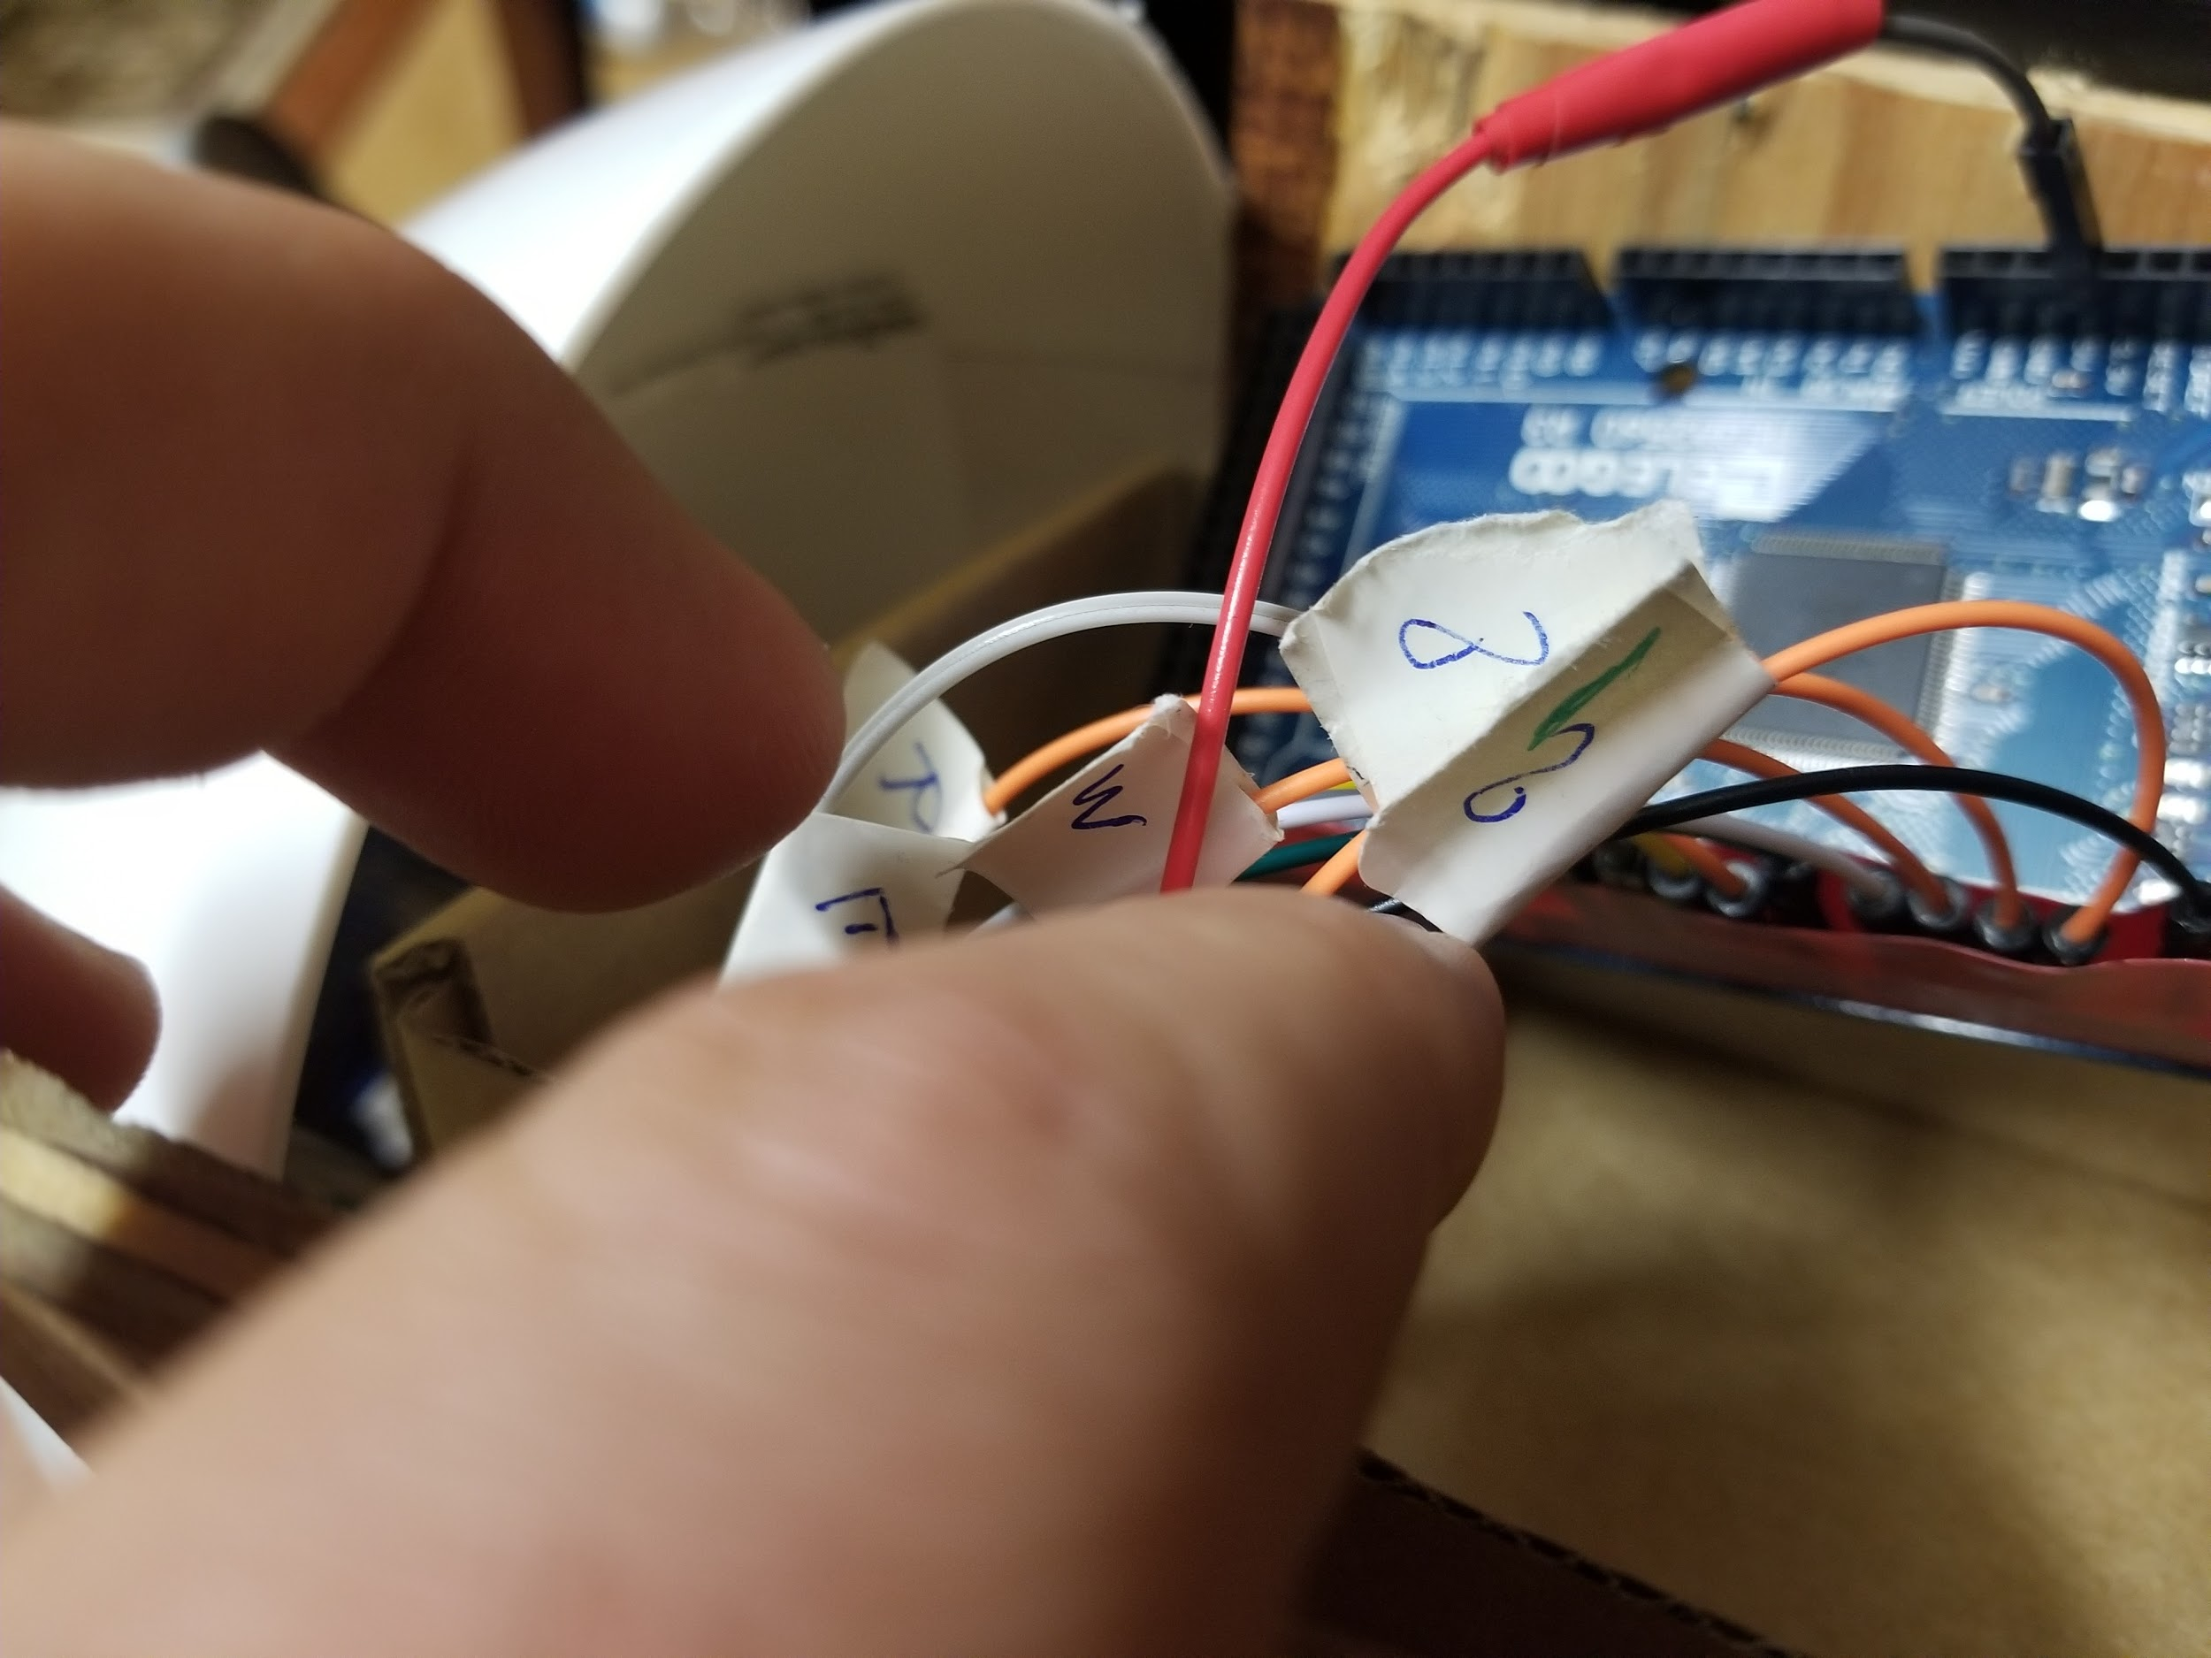

FIGURE 10.

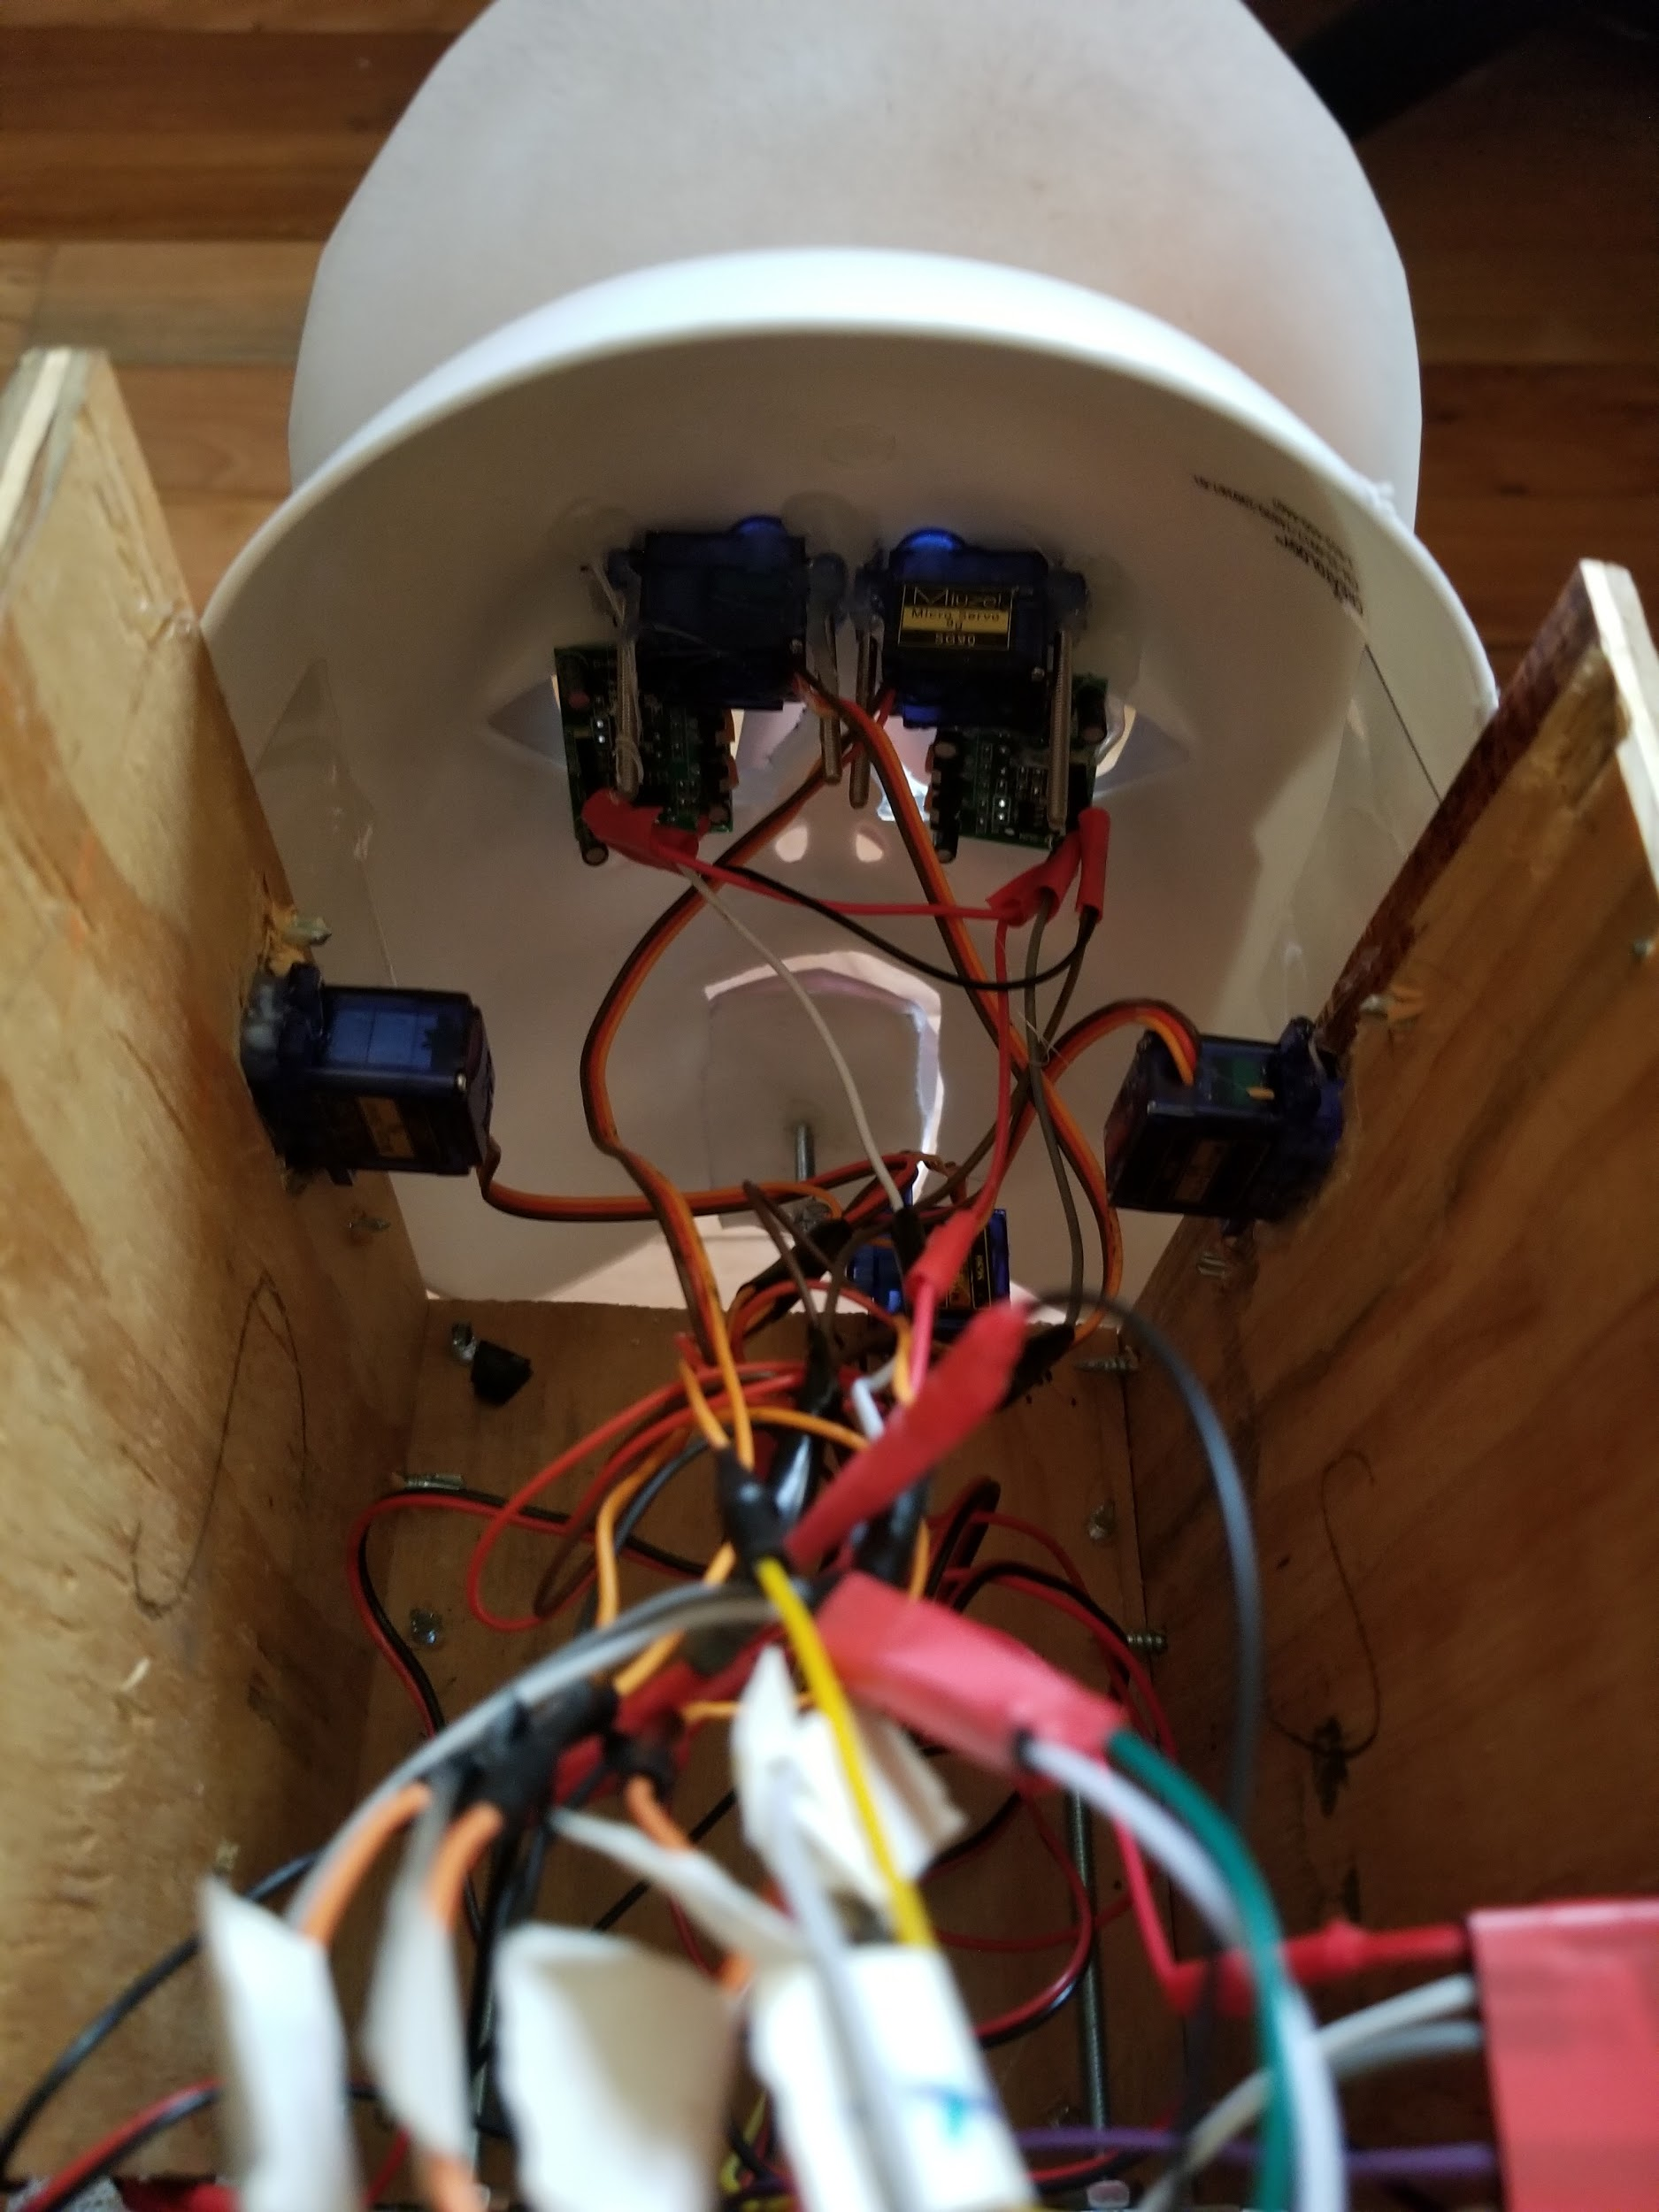

FIGURE 11.

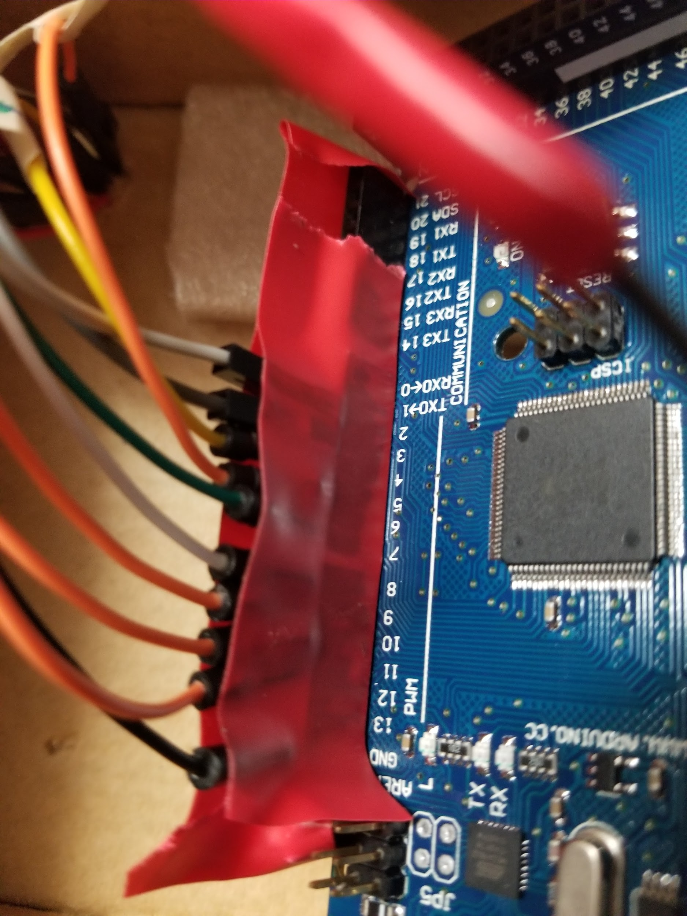

FIGURE 12.

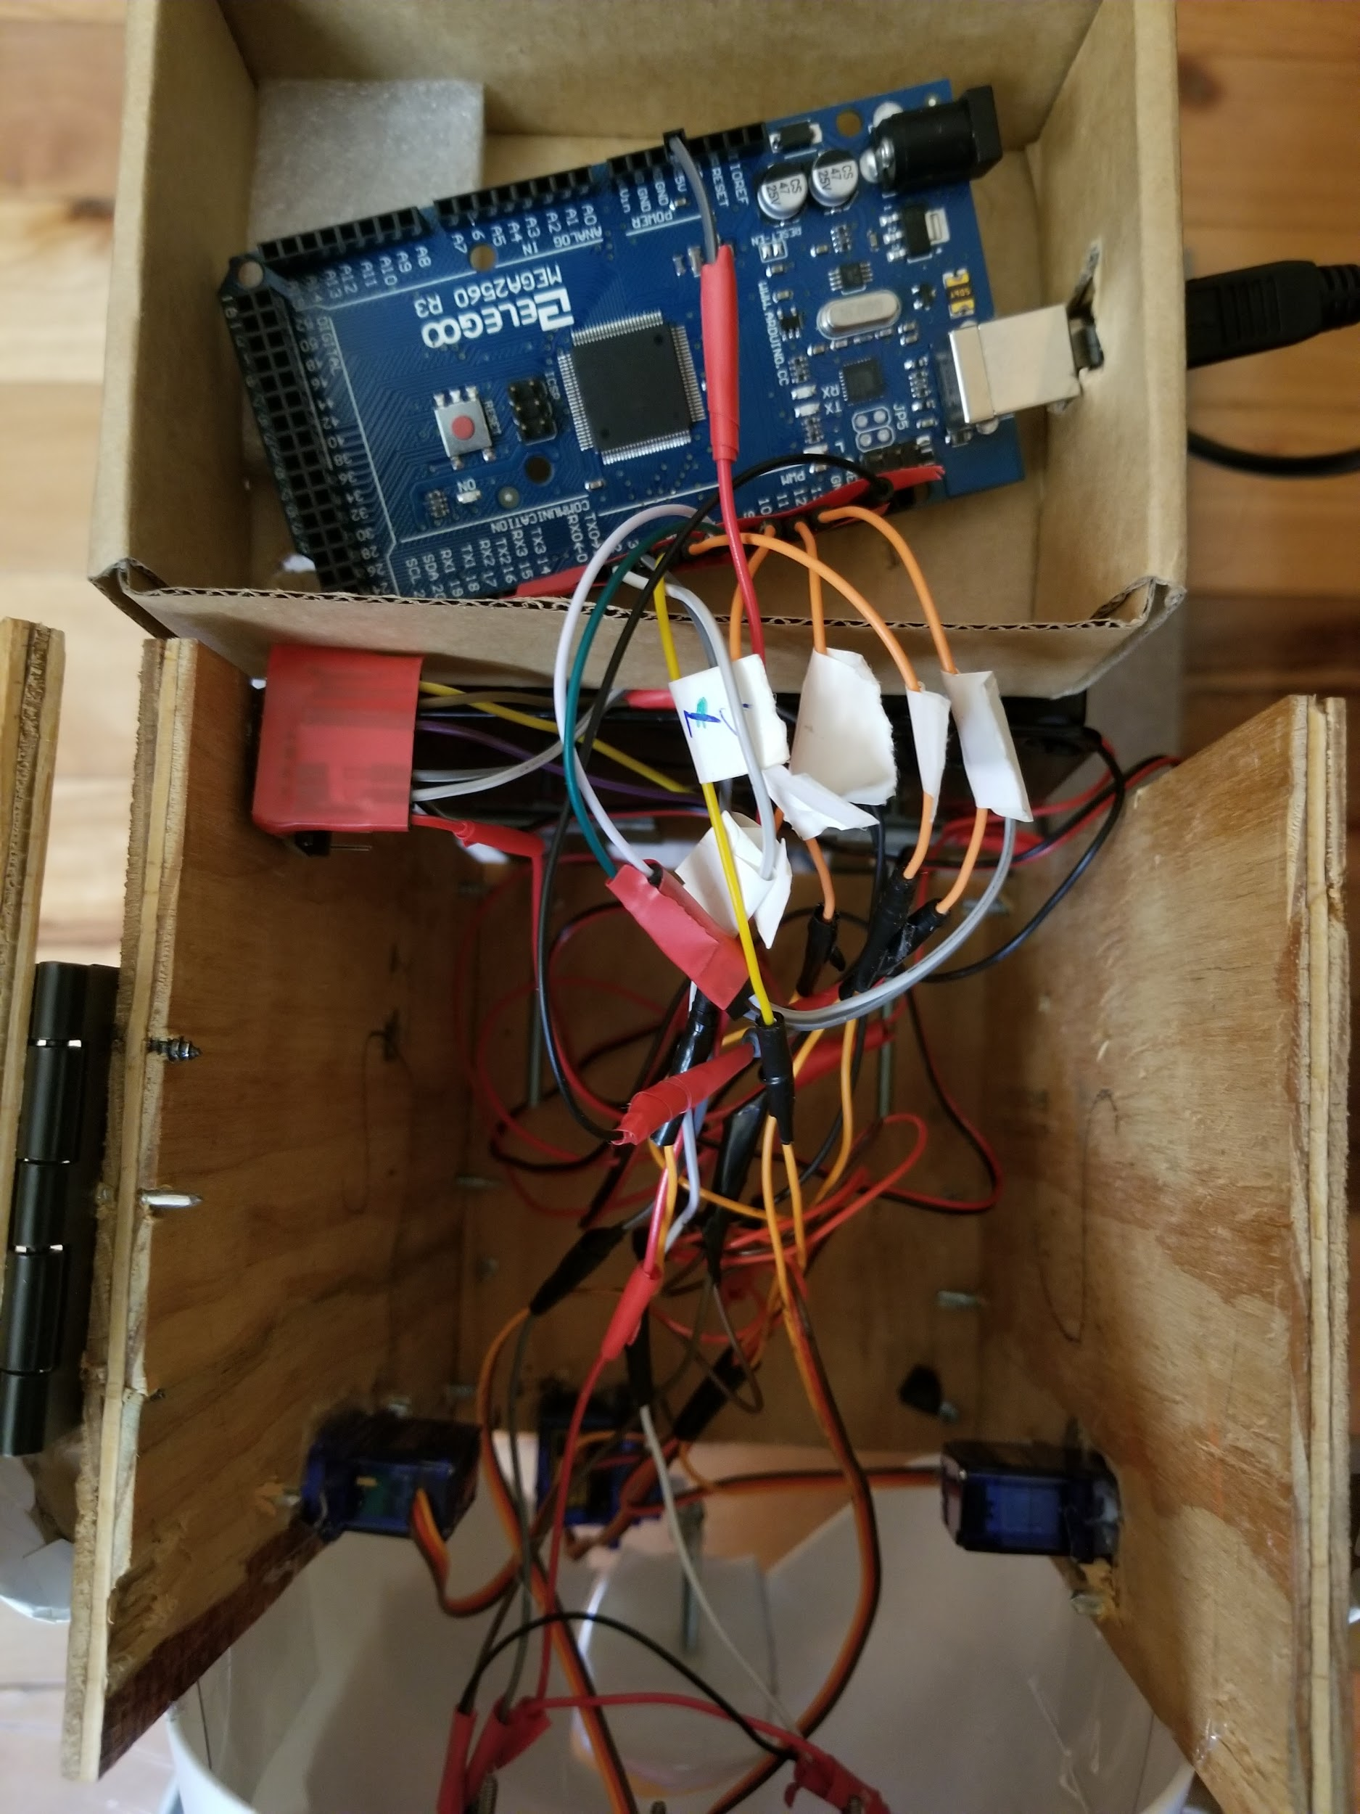

FIGURE 13.

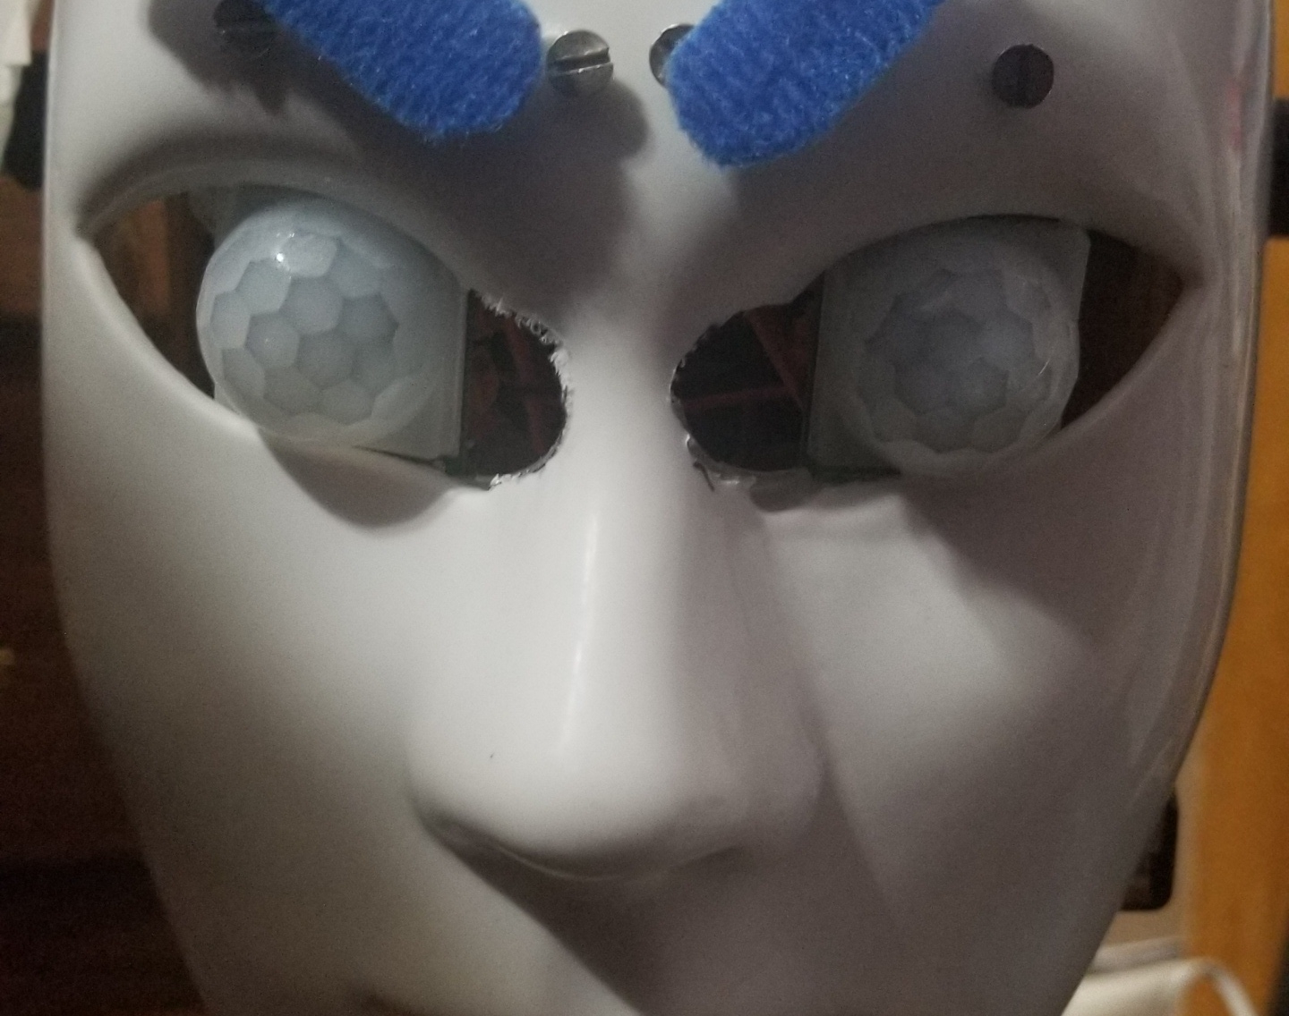

FIGURE 14.

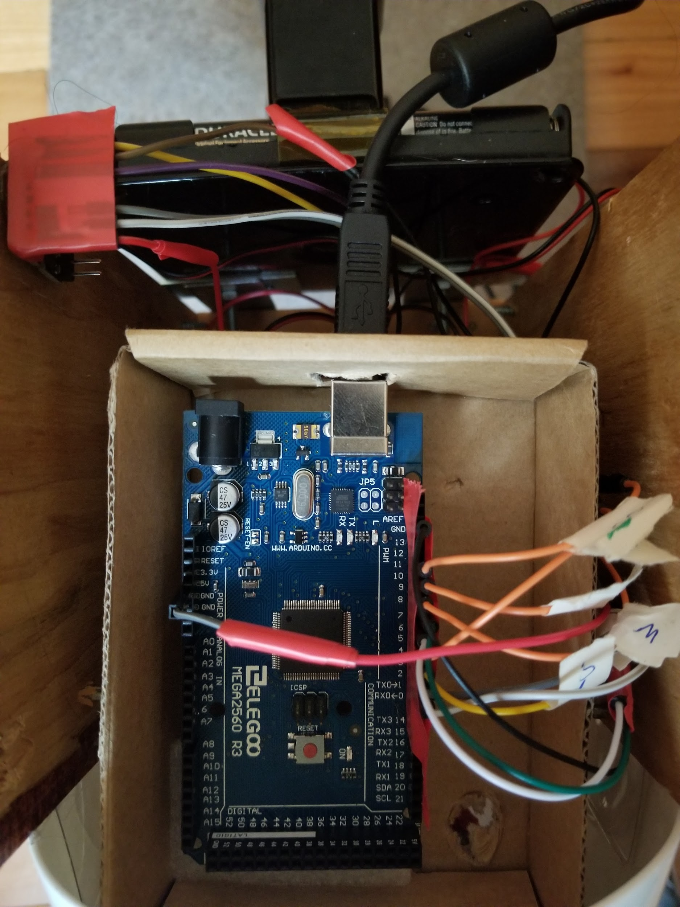

FIGURE 15,

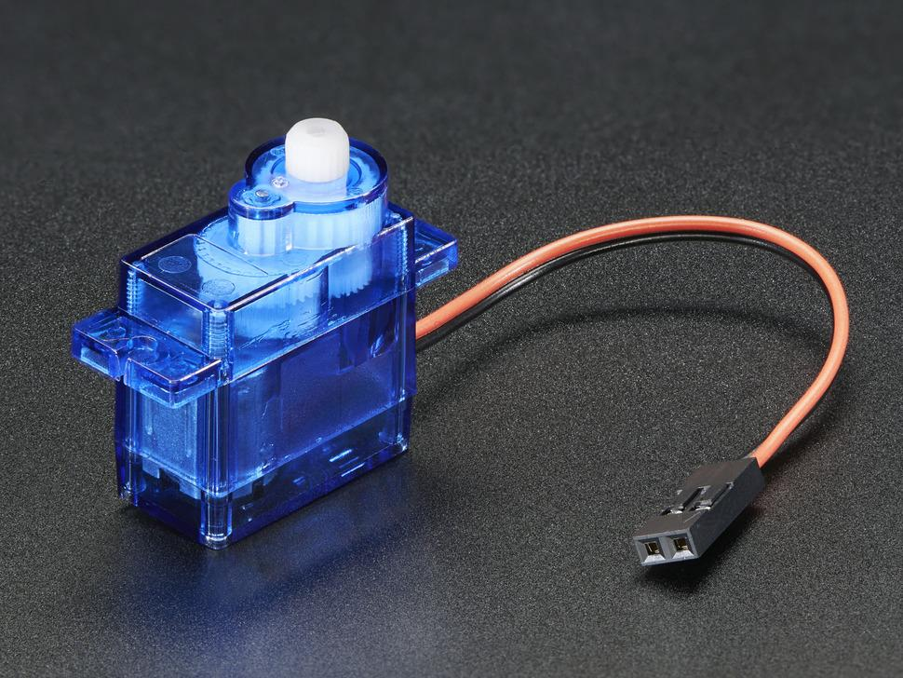

FIGURE 16.

**Appendix B: Code**

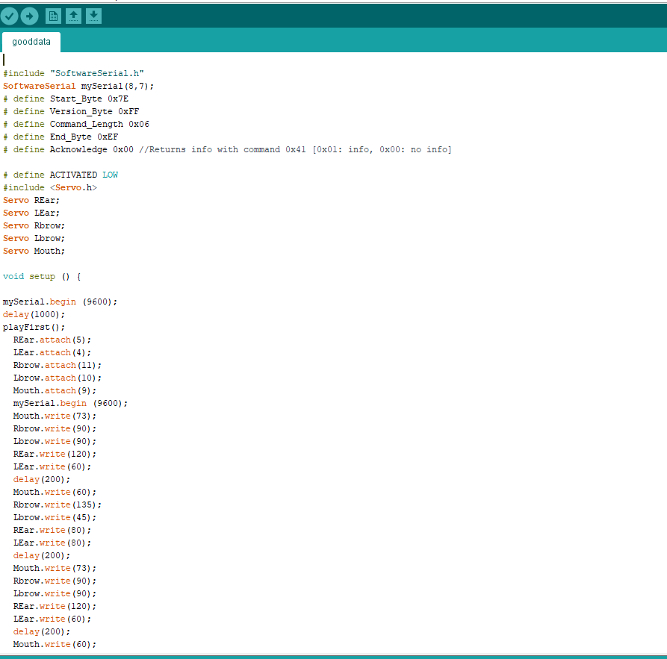



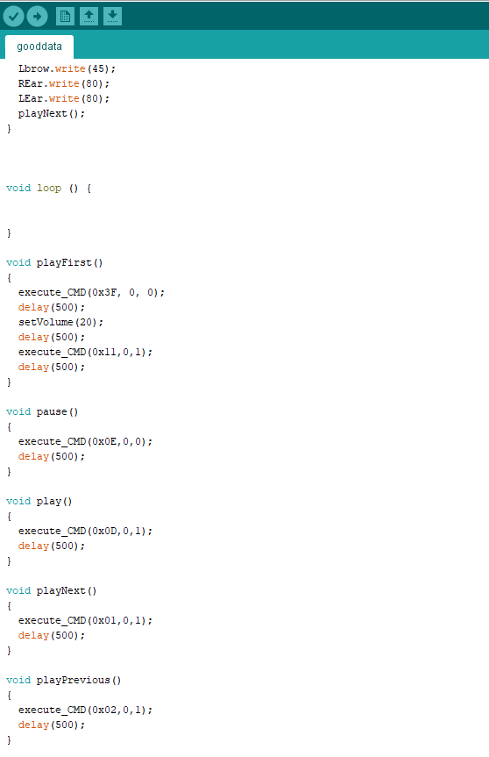

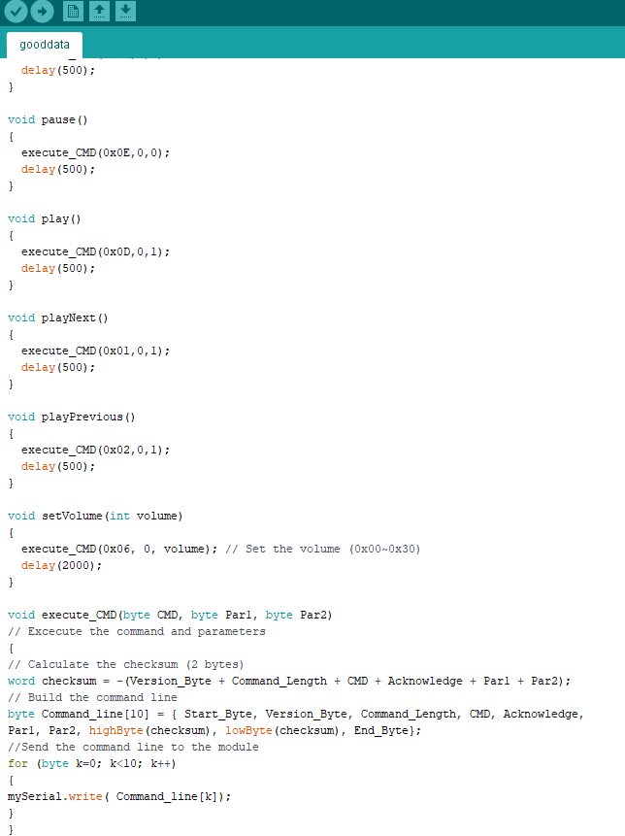

**Appendix C: Arduino wiring**

